


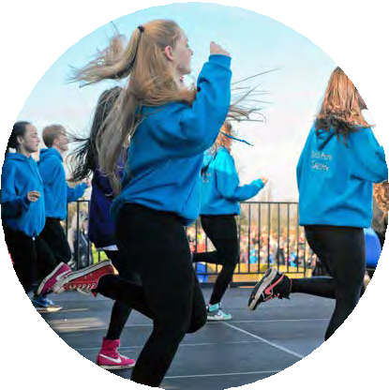
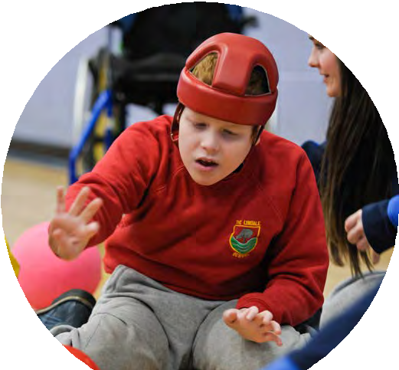
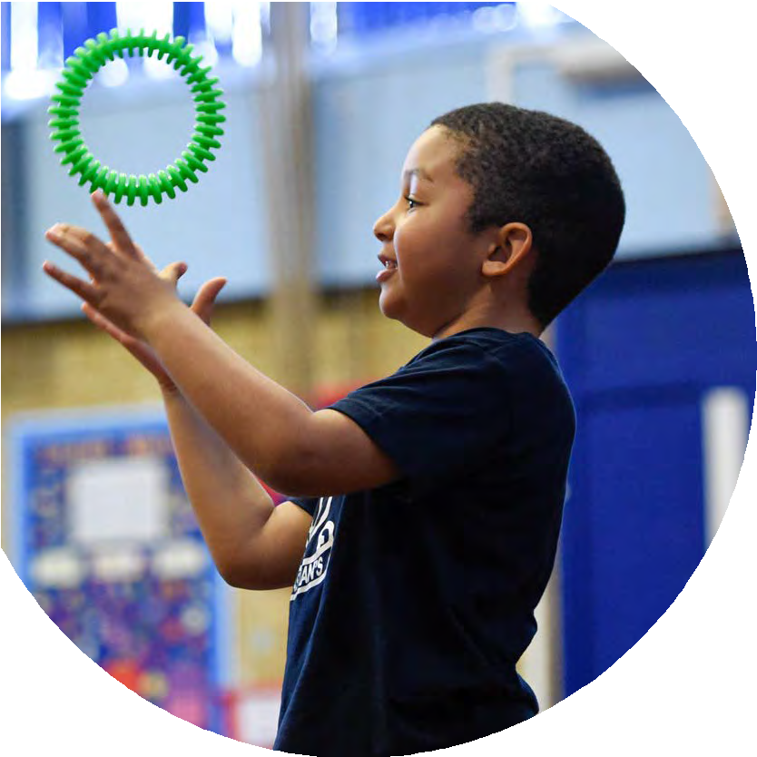



ABabbageA - A BABBAGE

The Primary PE and sport premium
Planning, reporting and evaluating website tool

LEONARD STANLEY PRIMARY SCHOOL
2025/2026
2024 - 2025



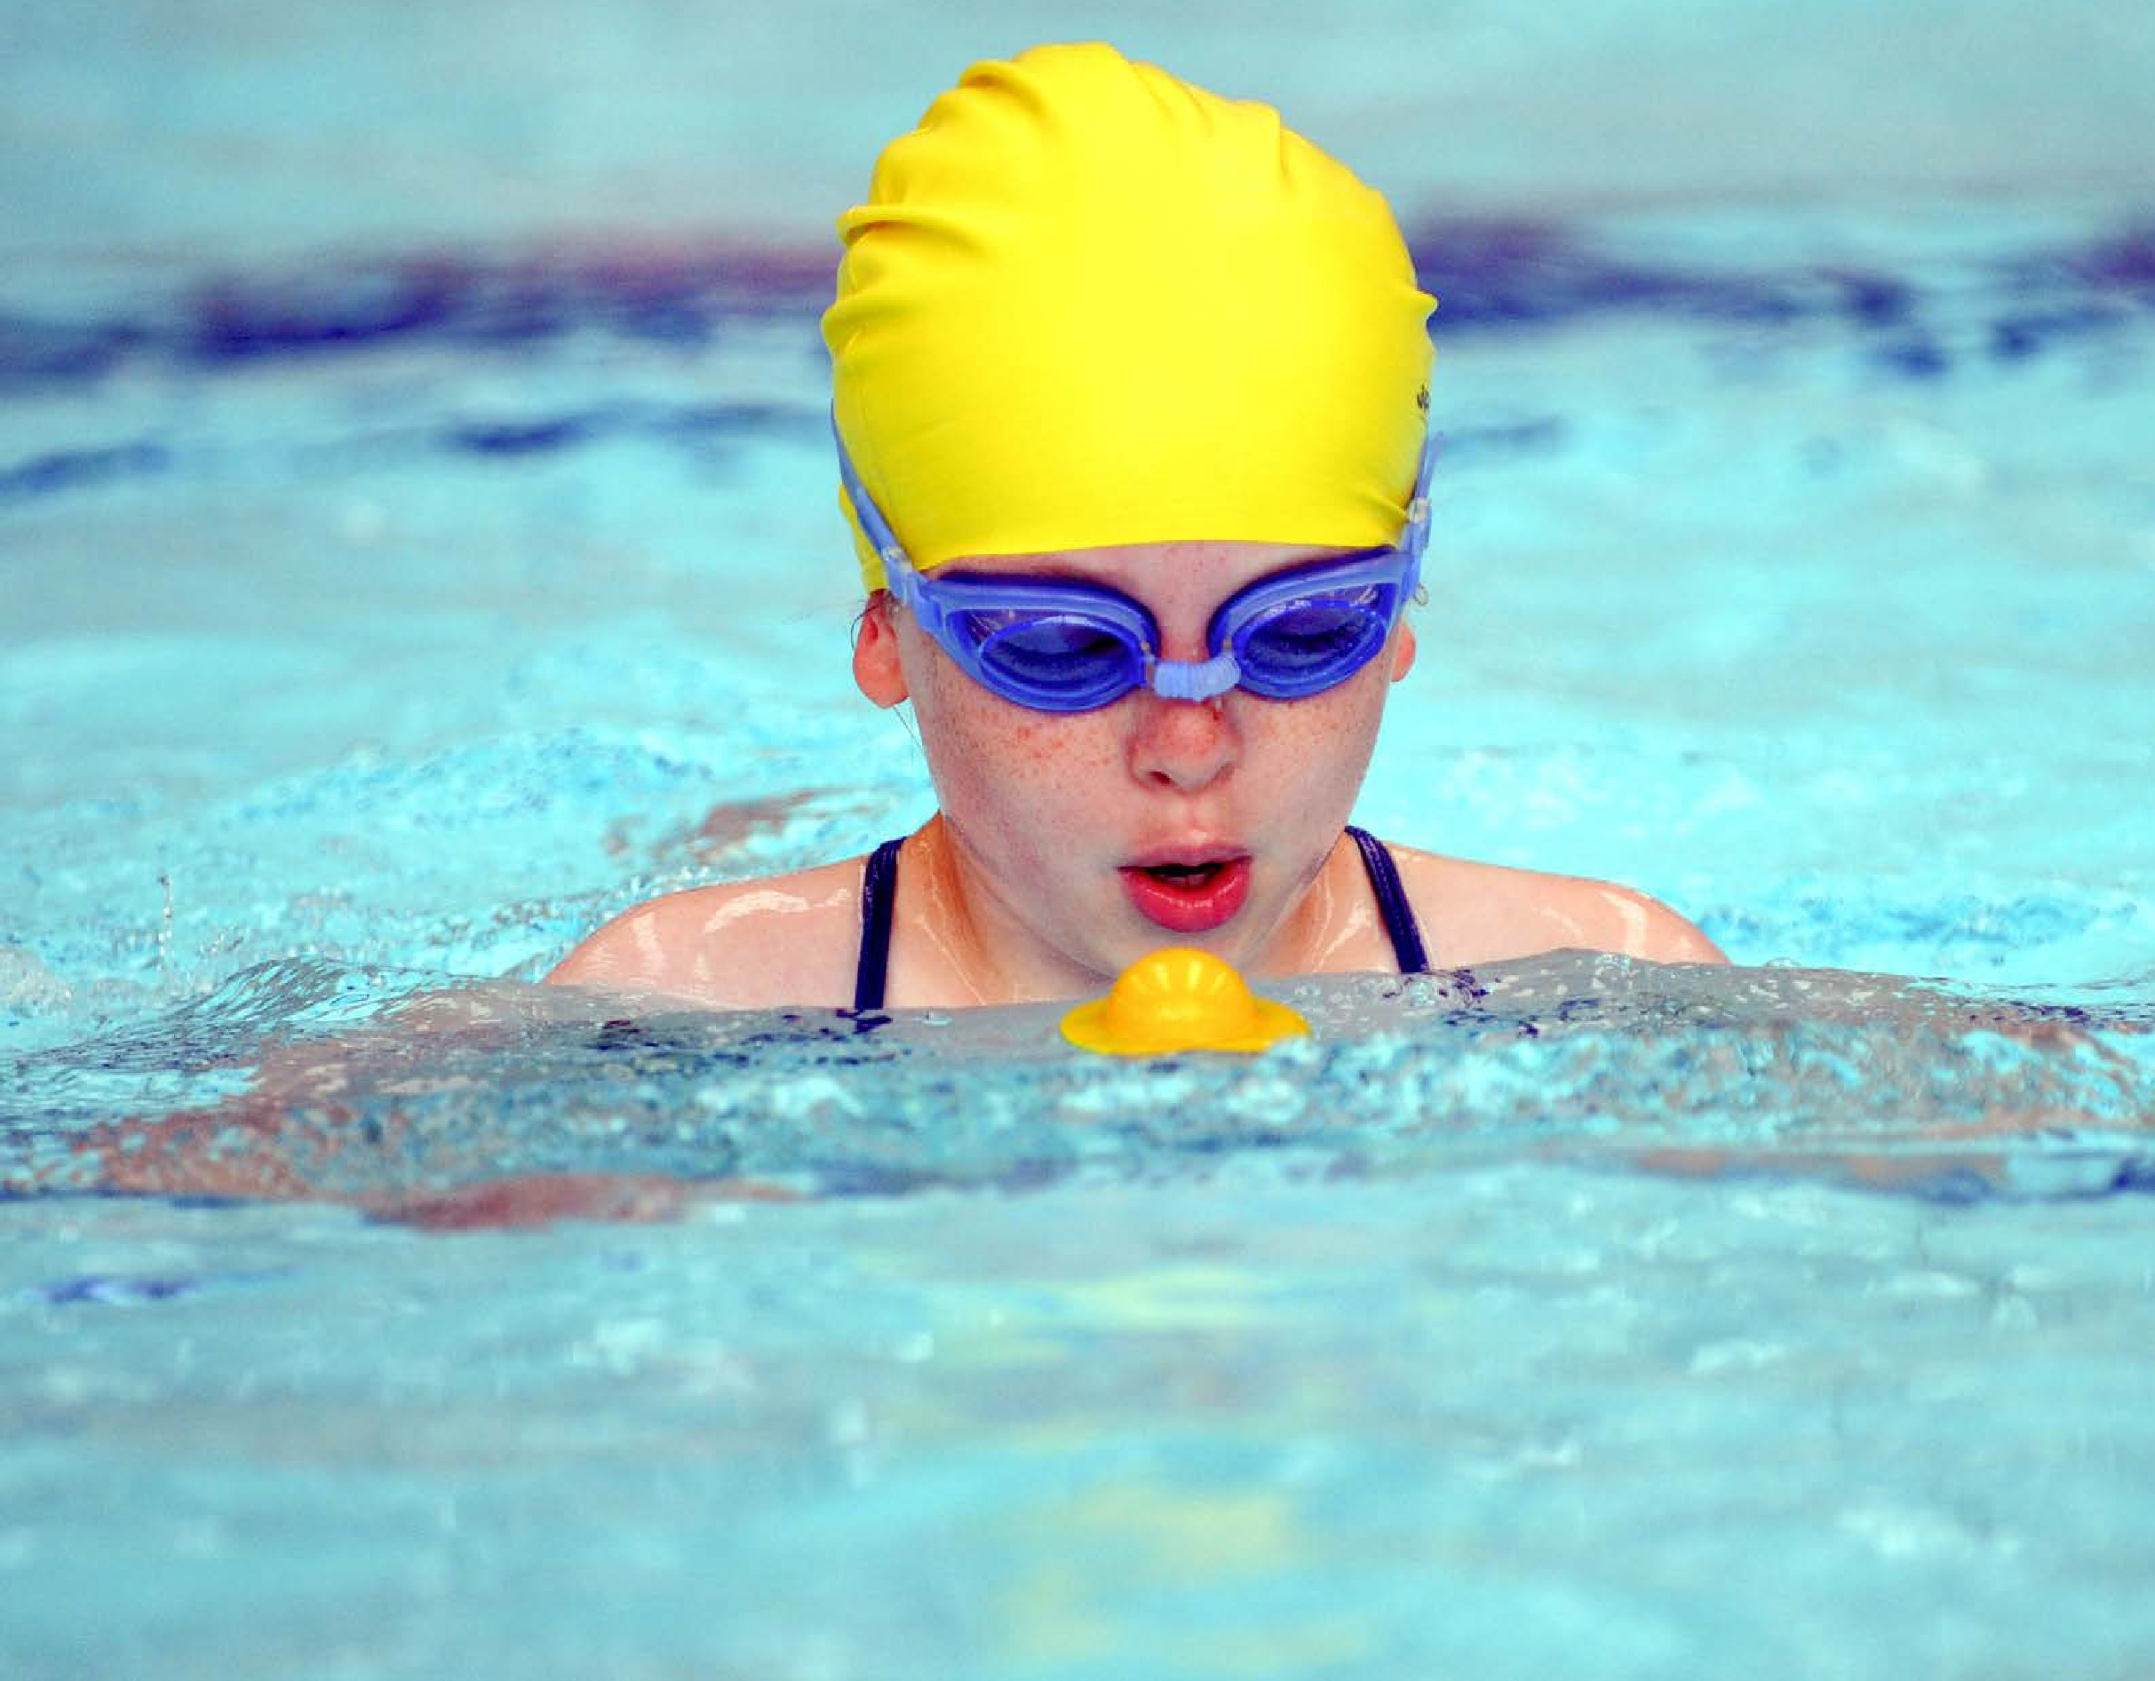
This template can be used for multiple purposes:

- It enables schools to effectively plan their use of the Primary PE and sport premium
- It helps schools to meet the requirements (as set out in guidance) to publish information on their Primary PE and sport premium
- It will be an effective document to support Ofsted inspections enabling schools to evidence progress in Physical Education (PE) and evidence swimming attainment, which forms part of the PE National Curriculum. We would recommend schools consider
the Intent, Implementation and Impact of any spend, as examined within the Education Inspection Framework.
It is important that your grant is used effectively and based on school need.
Schools must use the funding to make additional and sustainable
improvements to the quality of the PE, School Sport and Physical Activity (PESSPA)
they offer. This means that you should use the Primary PE and sport premium to:
- Build capacity and capability within the school to ensure that improvements made now will benefit pupils joining the school in future years
- Develop or add to the PESSPA activities that your school already offers.
The Primary PE and sport premium should not be used to fund capital spend projects; the school’s core budget should fund these. Further detail on capital expenditure can be found in the updated Primary PE and sport premium guidance.
The Primary PE and sport premium guidance, outlines 5 key priorities that funding should be used towards. It is not

necessary that spending has to meet all the key priorities, you should select the priorities that you aim to use any funding towards.
Although completing this template is not a requirement for schools, schools are required to publish details of how they spend this funding. Schools must also outline what the impact this funding has had on pupils’ PE and sport participation and attainment and how any spending will be sustainable in the future. All funding must be spent by 31st July 2026.
The Department for Education has worked closely with the Association for Physical Education (afPE) and the Youth Sport Trust (YST) to develop this template and encourages schools to use it. This template is an effective way of meeting the reporting requirements of the Primary PE and sport premium.
Review of last year’s spend and key achievements (2024/2025)
We recommend you start by reflecting on the impact of current provision and reviewing your previous spend.

Activity/Action | Impact | Comments
Entered a high % of events again. Have also entered more multiple teams ( increasing participation ) in competitions – eg 3 rugby, 5 hockey teams and whole classes.  Clubs have continued to run each term through teachers, TAs and Atlas – football, netball, rugby, cricket, rounders, Cheerleading, hockey, running, gymnastics and Fun Sports. This was across KS2 mainly, but more were introduce to KS1 this year too – football, Shonk.  High Quality Teaching promoted through PE specialism – Atlas / JA leading sessions across the school.  Looking at cost implications and value for money – school to charge for clubs paid in from outside agencies.  PE bags of kit ( bags containing a variety of sports kit for children to play with at break and lunch times ) very popular – well used to promote more active playing.  Y5/6 Young Sports Leaders used at lunchtimes to engage more children in sport and play, including more variety – archery, dodgeball, rugby, etc.  Begun Sports council – children chosen and class representatives – to develop their roles as Lunchtime captains – Y6s more - this will increase pupil voice and their contribution.  PE kit still well supported across the school – now an expectation from YR up to have the correct kit/ uniform – promoting belonging, being part of something and well-being. Batemans Shop still handles all PE kit sales – and with some prompting, going well.  “Daily mile” still occurs – on timetable, with wet activities seen in class if needed – ie Joe Wicks, Just Dance, etc.  Balanceability still embedded in YR and now started to develop more in EYs. Cycling also used in Y1 after 2 teachers trained on Cycling course – to build into curriculum in Y3 too. Purchased 16 more bikes Y1/3 sizes to help with whole class delivery.  Judo sessions offered again to Y1-4 children to promote well-being – learning new skills, being active, discipline, self-control, etc.  Swimming remains good, high % of children swimming well in Stratford Park and our school pool. 84% of last year’s Y6s can swim the required 25m, and more predicted to achieve this year  Residential days (3) – was a great success at Viney Hill – with most children participating over the week.  Third year running, school achieved a GOLD SPORTSMARK accreditation! Recognising the strong role PE plays in our school. | All Y1, 2, 4, 5, 6 children have participated in a Stroud level or School Games event, with many of Y3 also attending. Overall 96% ( up from 85%) of children in the school have participated - 93% of children in KS2, 100% of KS1.  More children attending clubs and accessing more physical activity and hitting daily / weekly activity levels required.  Variety of clubs offered – eg Cheerleading, Funs.  Dance teacher unable this year – to contact again for next!  Quality of teaching strong with trained agencies running lessons and activities.  Kit bags used again by KS1 and all 4 KS2 classes to increase activity levels of most, and improve more physical play.  Some bags set up for different clubs / sports. But still dependent on weather – to develop a more robust structure to have regular varied experiences, inc KS1 more.  Council met each term. Bags and YSL set up and supported by Council.  All YR children joined with PE uniform / kit. Still promoted in classes and an expectation for all. Link sent to parents and reminded regularly in Newsletters and correspondences.  Timetabled still – but to reduce time (as not as focused as needed!  YR / EYs children again received training and use of balance bikes.  Y1 and Y3 had block of lessons to develop cycling / pedaling skills – with all able to ride at the end. Built into PE coverage  All children Y1-4 accessed Judo – a new skill again – to improve discipline, self-control skills and linking to well-being and PSHE understanding.  Continue to take children to Stratford park and support coach cost shortfall, so all can go.  Swimming over 4 terms not 6, was a positive move, despite school pool being shut, and more parents did pay.  Children accessed Activity week – with it being a lot cheaper.  School recognized for provision of PE and physical activities across school. To continue high levels next year. | More children developing more enjoyment for physical activities – with some attending and joining clubs more because of this.  Clubs were, however, a little light of numbers in a few places – SL to review clubs, ages offered, and use Pupil voice and Sports Council to find out again what clubs would be wanted.  Cheerleading numbers good. Dance teacher had a baby, but offered to run in 25/26  Look at more use of outside, trained agencies and sports leaders.  SLT to look at payments for outside clubs to reduce impact on Sports Premium.  Top up resources in bags – audit what’s needed.  Discuss role of Sports council to ensure care taken with kit.  SL to set up stronger provision and structure for Aut term and Summer term ( where weather more suitable to field use)  Meet more regularly and discuss/ set up what role of Sp Council is – defined job description  SL lead to monitor use of kit in school.  SL and HT to looked at new Curriculum design and timetable design to set available time.  To reinforce in Y3 – added to new curriculum design for PE – which will support Biking in Y5/6 ready for competition.  Popular with children and teachers. Will be good for classes like Y1 this year as 20/ 26 boys!! Y1 given extended term to support an active class and develop focus and self control.  Pool open – after discussion with HT the school will stop using Stratford Park, and the school pool will be used in the Summer 2 term – satisfying our swimming needs ( approx. 21 lessons for each class YR-6). This will reduce costs incurred/ covered by school, with budget to balance.  School to book Viney Hill for 2 nights/ 3 days residential again. Cheaper and more affordable, and more local for all to access – people can travel down if needed.  Keep council focus, high % attending competitions (with multiple teams) and clubs, and maintain provision for those with SEND and less interested.

Key priorities and Planning
This planning template will allow schools to accurately plan their spending.

TOTAL SPEND FOR CPD CATEGORIES:
Action – what are you planning to do | Who does this action impact? | Key indicator to meet | Impacts and how sustainability will be achieved? | Cost linked to the action
EXTERNAL TRAINING COURSES
Register for Access to ATLAS package for Comps - GOLD  SL to register and SBM to pay invoice | SL – register paperwork – package and competition enrollment; monitor who attends and keep registers  SBM – pay invoice  SL to open up training opportunities to all staff in line with Atlas package | Key Indicator 1: Increased confidence, knowledge, and skills of all staff in teaching PE and sport. | Staff use CPD opportunities (TBC) to develop skills and knowledge in PE – run by Atlas. Staff request activities to ATLAS as needed.  SL sends out audit/ questionnaire to staff to gather needs regarding PE across the school – to focus training undertaken or future needs – to maintain high levels of PE provision at LS. | £500
UPSKILLING STAFF TO DELIVER SWIMMING LESSONS:
In-house development of a swimming scheme of work for all classes. | SL to discuss key ideas, activities and stroke development techniques to use in our School Pool lessons.  Set up expectations for each Key Stage / Year group if possible.  Consult other schemes (eg ASA) and other useful resources to signpost to staff / put on Google drive. | Key Indicator 1: Increased confidence, knowledge, and skills of all staff in teaching PE and sport. | Teachers will have structure to follow in delivering Swimming instructions.  Children will all be able to swim 25 m at end of Y6. | £0
INTERNAL LEARNING AND DEVELOPMENT:
INTER-SCHOOL DEVELOPMENT SESSIONS:
Sports Council meet termly to support PE across school | SL – organize meetings.  Ts and classes to choose reps.  Children to act as Captains , YSLs and participants.  Job description to be written with Council – to clearly define roles and when they are required – ie marshal reindeer run, stickers in celebration, look after bags, etc. | Key Indicator 3: The profile of PE and sport is raised across the school as a tool for whole-school improvement | Sports council reps are chosen to support “House Captains” (chosen from Y6 in July).  Council meet termly to discuss role (job description drawn up by SL) to look at termly focusses – eg bags, clubs, YSLs, future actions / needs. (Minuted)  Council take survey of groups and report on findings – set actions. | 0
ONLINE TRAINING / RESOURCE DEVELOPMENT:
EXTERNAL COACHES SUPPORTING CONFIDENCE AND COMPETENCE:
Hire of Atlas teacher on Friday for PE support and to run ASC. | SL to liaise with Atlas to organize teacher, and focus to class needs across the year.  T – to work with Teacher to develop current practice. | Key Indicator 1: Increased confidence, knowledge, and skills of all staff in teaching PE and sport. | Teacher from Atlas teaches class each week – demonstrating High quality teacher to model for teachers to support practice.  ASC run according to needs of the school – offered to children. | Cost - £5000
TOTAL SPENDING ON CPD: |  |  |  | £5500
SPENDING CATEGORIES - INTERNAL:
Action – what are you planning to do | Who does this action impact? | Key indicator to meet | Impacts and how sustainability will be achieved? | Cost linked to the action
SCHOOL BASED EXTRA CURRICULAR OPPORTUNITIES:
KJ to run FIZZY PE group clubs to support development of SEND children and those with motor skill needs  To encompass After school “fun club” and KS2 PE Games group to allow 5 groups and have SEND/ less able focus group.  To encourage participation of these focus children in more Inclusive events, and instill enjoyment for PE. | KJ – running club  TAs supporting club  Ts – support timetabling with KJ and identify children  Children attending  SENCO – support TA monitoring and needs of children on My Plans | Key indicator 5: Increased participation in competitive sport  Key indicator 4: Broader experience of a range of sports and activities offered to all pupils. | Regular sessions (Wed/ Thurs) of Fizzy to support focused children run by KJ, timetabled with staff.  KJ to run 5th PE Games group for KS2 carousel Fridays, allowing for smaller groups and a focused SEND group.  KJ and TA run Fun Club after school for children – targeted!!  KJ and Tas take children to the 3 / 4 inclusive events on offer in package each year | KJ money - £2000 ( 3hrs per week – 2 fizzy , 1 PE group)
INTERNAL SPORTS COMPETITIONS:
Ensure high levels of activity across a school day/ week. | SL – to monitor; audit equipment, purchase new/more equipment; to ask Council for support and hear needs, meeting termly; train YSLs and ensure activities offered, run properly, and purchase/organized kit needed.  Council – monitor bags, suggest kit needed, or request more/ new, to ensure class respect and keep kit properly  YSL – to offer sessions to run, organize kit, and supervise sessions at lunch time.  SL / SLT to look at use of field even when wet – to develop use of outside space better | Key indicator 2 -The engagement of all pupils in regular physical activity – the Chief Medical Officer guidelines recommend that all children and young people aged 5 to 18 engage in at least 60 minutes of physical activity per day, of which 30 minutes should be in school.  Key Indicator 3: The profile of PE and sport is raised across the school as a tool for whole-school improvement  Key indicator 4: Broader experience of a range of sports and activities offered to all pupils. | Daily breather outside or daily activity on school timetable.  PE bags available to all children/ classes to encourage more games, play and participation in activities.  YSL trained and organized to set up and run sporting activities (eg dodgeball, tag rugby, football, etc) at lunch times – weather dependent!  A wide variety of clubs is offered termly, including more inclusive clubs – with registers kept and monitored to be able to invite non-attenders, and offer newer clubs to interest a wider group.  Council survey of interests/ needs – to offer more clubs.  Council and YSL children to support Ts / Tas running clubs and be extra helpers. | Bags of equipment – for class and YSLs _ audited, monitored and topped up by Sports Council and SL.  £1000
TOP-UP SWIMMING LESSONS OR BROADENING AQUATIC OPPORTUNITIES FOR PUPILS:
ACTIVE TRAVEL:
EQUIPMENT AND RESOURCES:
New equipment – replacing lost/ damaged kit, Sports Day trophy, including storage?!  ( On top of – PT bags / YSL bags ), | SL – to audit/ monitor kit – produce order for SBM to process.  SBM to order kit  Council – to monitor kit and suggest needs. | Key indicator 4: Broader experience of a range of sports and activities offered to all pupils. |  | Approx £1000
MEMBERSHIP FEES:
USE OF EDUCATIONAL PLATFORMS AND RESOURCES:
To improve well being and mindfulness across the school | HT / SENCO to purchase My Happy minds online programme,  Teachers to deliver regular lessons over the year. | Key Indicator 3: The profile of PE and sport is raised across the school as a tool for whole-school improvement  Key indicator 4: Broader experience of a range of sports and activities offered to all pupils. | Children will understand how their brains / bodies work.  Children will be able to regulate their emotions and behaviors better | £2500 for package
TOTAL SPENDING ON INTERNAL: |  |  |  | £6500
SPENDING CATEGORIES - EXTERNAL:
Action – what are you planning to do | Who does this action impact? | Key indicator to meet | Impacts and how sustainability will be achieved? | Cost linked to the action
ACTIVITIES ORGANISED BY SCHOOL GAMES ORGANISER NETWORK:
Register for Access to ATLAS package for Comps - GOLD  SL to register and SBM to pay invoice | SL – register paperwork – package and competition enrollment; monitor who attends and keep registers  SBM – pay invoice  All pupils – attending  SL to open up training opportunities to all staff in line with Atlas package | Key indicator 5: Increased participation in competitive sport.  Key indicator 4: Broader experience of a range of sports and activities offered to all pupils  Key Indicator 1: Increased confidence, knowledge, and skills of all staff in teaching PE and sport. | Hit target (85+%) of pupils to attend competitions, from Y1-6  Register attendance across school to monitor who has had chances and who to target. | £1500
Maintain high % of children attending sports competitions. | SL - monitor who attends and keep registers  Ts and Tas – to support with attending comps  All pupils - attending | Key indicator 5: Increased participation in competitive sport.  Key indicator 4: Broader experience of a range of sports and activities offered to all pupils | Register attendance across school to monitor who has had chances and who to target.  School attends all SEND/ Inclusive competitions to maintain opportunity for all children  School to send multiple teams ( eg 3 teams to Quadkids – all Y4s, 3 teamd to Y2 Dodgeball, All Y5/6s to go to Sportshall event – 2 teams, etc) | As Gold package!
Achieve Gold / Platinum award for Active schools | SL – to monitor PE and activity levels across school year, and with ATLAS support complete paperwork for application after 2 Gold years already. | Key Indicator 3: The profile of PE and sport is raised across the school as a tool for whole-school improvement | SL keeps data for competition and club attendance – via edulink forms.  School attends most / a very wide variety of competitions.  SL applies for Active Schools Accreditation - successfully | 0
Hiring Supply teachers to cover teacher’s classes as they attend comps | SL to liaise with staff to organize who attends activities;  SL to request supply cover from SBM | Key indicator 5: Increased participation in competitive sport  Key indicator 4: Broader experience of a range of sports and activities offered to all pupils. | Children attend competitions with necessary staff.  Supply teachers cover/ teach classes.  A high % of children attend a wide variety of events. | Supply costs approx. £1400
Hiring Coach / bus / taxis to transport children to comps | SL / KJ – to discuss/ plan transport needs and request coach/ bus/ taxi hire from SBM | Key indicator 5: Increased participation in competitive sport  Key indicator 4: Broader experience of a range of sports and activities offered to all pupils. | Transport arranged to take children to events.  A high % of children attend a wide variety of events. | Coach / taxi/ minibus hire – approx. £1500
OTHER INTER-SCHOOL SPORTS COMPETITIONS:
EXTERNAL COACHING STAFF:
Judo Wellbeing sessions for Y1-4 children. | SL to liaise with Richard Neal ( Judo Coach) and class teachers to organize date/ times etc. | Key indicator 5: Increased participation in competitive sport  Key indicator 4: Broader experience of a range of sports and activities offered to all pupils. | To improve concentration / self control / develop a new skill / gain interest to join the external club and improve lifestyle for the future. | £1200
Introduce external DANCE TEACHER to the school for children to access. | SL to liaise with Mya Roberts( Dance teacher) and class teachers to organize date/ times etc.  Set up Edulink club to book in.  Set up Parent Pay request to book places. | Key indicator 5: Increased participation in competitive sport  Key indicator 4: Broader experience of a range of sports and activities offered to all pupils. | To improve activity levels of more children over a week.  Add links to external clubs and opportunities. | £60 ( to cover short fall and PP children).
TOTAL SPENDING ON EXTERNAL: |  |  |  | £5660
TOTAL SPENDING OF SPORTS PREMIUM: |  |  |  | £17660  (£17660)
Key Indicator 1: Increased confidence, knowledge, and skills of all staff in teaching PE and sport. | Key indicator 2 -The engagement of all pupils in regular physical activity – the Chief Medical Officer guidelines recommend that all children and young people aged 5 to 18 engage in at least 60 minutes of physical activity per day, of which 30 minutes should be in school. | Key Indicator 3: The profile of PE and sport is raised across the school as a tool for whole-school improvement | Key indicator 4: Broader experience of a range of sports and activities offered to all pupils. | Key indicator 5: Increased participation in competitive sport.

Key achievements 2025-2026
This template will be completed at the end of the academic year and will showcase the key achievements schools have made with their Primary PE and sport premium spending.

Activity/Action | Impact | Comments
Maintain high % of children attending sports competitions. [ every child attends at least one event over the year]
Fizzy Interventions run – improving key motor skills ( fine and gross ) to support learning in the classroom.
Staff receive appropriate CPD – eg show equipment in container and how to use effectively ( ie – kurling for Eys; swimming ideas and scheme of work
High levels of activity available across a school day – inc break times/ after school / in the timetable.
Achieve GOLD award again for Active schools - 4th year

Sports Council meet termly to support PE across school – to have a structured role (Job description written – stickers in celebration assembly; monitoring, tidying PE bags for break times; clear up equipment ( container tidy!?)

Purchase and monitor impact of My Happy Minds programme,
Appropriate resources available in school for lessons - Audit equipment – purchase to fill gaps and support teaching requirements
Residential trip for Y6 still enjoyed and works well
Swimming provision still good, without Leisure centre use.

Swimming Data
Meeting National Curriculum requirements for swimming and water safety.
Priority should always be given to ensuring that pupils can perform safe self-rescue even if they do not fully meet the first two requirements of the National Curriculum programme of study

Question | Stats: | Further context  Relative to local challenges
What percentage of your current Year 6 cohort can swim competently, confidently and proficiently over a distance of at least 25 metres? | 83% | Current Y5s moving to Y6 July 2024.
What percentage of your current Year 6 cohort can use a range of strokes effectively [for example, front crawl, backstroke, and breaststroke]? | 53% | Current Y5s moving to Y6 July 2024.
What percentage of your current Year 6 cohort are able to perform safe self-rescue in different water-based situations? | 0% | Covered in Y6 lessons / curriculum
If your schools swimming data is below national expectation, you can choose to use the Primary PE and sport premium to provide additional top-up sessions for those pupils that did not meet National Curriculum requirements after the completion of core lessons. Have you done this? | Yes/No
Have you provided CPD to improve the knowledge and confidence of staff to be able to teach swimming and water safety? | Yes/No | Paid for and carried out by trained staff at Stratford Park Leisure Centre.

Signed off by:

Head Teacher: | Andrew Milner
Subject Leader or the individual responsible for the Primary PE and sport premium: | Andy Babbage – Deputy Head / PE SL
Governor: | Dean Ackland PE Gov
Date: | July 2024

